A Review of “Sailing” Game by Using Software Evaluation System:
A Computer-based Game to Intertwine Various Mathematics Concepts and to Develop Students’ Creativity

Ariyadi Wijaya
Mathematics Education Department
Faculty of Mathematics and Natural Science – Yogyakarta State University

In modern era, the development of technology should be of concern to the practice of education. Developmentally appropriate computer software, as products of technology, benefit students’ learning process since computer software fit young children’s learning style and support participatory learning. “Sailing” game is a computer-based game developed by Freudenthal Institute – Utrecht University, the Netherlands that is used for mathematics learning. Although the main mathematics topic in this game is Angle, this game intertwines various mathematics concept, such as: , namely about angle. In general, the explorative characteristic of “Sailing” game benefits to develop students’ creativity. From mathematics point of view, this game supports students’ learning of angle and also develops students’ problem solving skill. Furthermore, this game applies the intertwinement characteristic of Realistic Mathematics Education that can be used to introduce the concept of indirect proportion and Pythagorean Theorem.
Keywords: “Sailing” game, concept of angle, students’ creativity

- Introduction
Science and technology are developing simultaneously and should support each other. Therefore, in the global era we should take the advantage of technology to support our education, as the producer of science and technology. Computer, as one of the products of technology, can be used to support education since computer technology provides various programs/software including computer-based game. Computer-based games can be applied to support students’ learning process when traditional methods are inadequate to reach the objectives of learning process.
According to Pietarinen (2003), there are two reasons that underpin the employment of games in education, namely:
- Technical reason
Games provide an interpretational device whenever traditional approaches turn out to be inadequate.
- Methodological reason
Games guide us towards a deeper understanding of the concepts and activities involved in cognitive reasoning processes.

In addition to these two reasons, the use of appropriate computer experiences including computer-based games offers many benefits for the learning process, such as:
- Fits young children’s learning style
- Participatory learning
- Holistic learning environment
- Intrinsic motivation
- Opportunities for Scaffolding
- Connecting children to the world
- Universal access to information
- Computers connect people

The use of game in education is in line with the idea of Buys & de Moor (2005) and Castle & Needham (2007) who believe that the foundation of mathematics education in kindergarten and elementary school needs to be laid on doing meaningful activities or experiences, through which a connection is made between informal knowledge and the formal concepts of mathematics. Consequently, it is important to give young children experience-based activities that embody some basic concepts of mathematics. Experience-based activities are relevant with Freudenthal’s idea that stresses mathematics as a human activity, instead of subject matter that has to be transmitted (Freudenthal, 1991). Freudenthal (ibid) proposed the need to connect mathematics to reality through problem situation because experience-based activities could contribute to the emerging of mathematical practices. For young children, game playing could be a problem situation, which is experientially real for them and, therefore, can be used as a starting point for their learning process. Game playing can form a natural part of the experience-based and development-focused activities for the teaching and learning of mathematics.
Considering the importance and benefit of games to support students’ learning process, this article will provide information about potential benefit of a computer-based game called “Sailing” game to support students’ understanding on the concept of angle and to develop students’ creativity.

- Principle for Selecting Software
Although computer offers many advantages or benefits, computer also has some potential disadvantages, such as: replacing other activities, providing children an unrealistic image of the world, and preventing children from social interaction. Therefore, we need to select appropriate computer program that will be used for education. Selecting high quality software from enormous software is a tremendous challenge. Survey of early childhood teachers shows that teachers have difficulty in selecting good quality software for their students (Haughland, 1997). Consequently, software evaluation system needs to be developed to guide teachers in selecting educational software. Software evaluation system can help teachers to determine whether educational software meets students’ interests and needs. The most important factor in using a software evaluation system is choosing the system that is congruent with teachers’ philosophical approach. Haughland & Shade in Haughland (2007) mentioned seven software systems which have evaluated a significant quantity of early childhood software. These seven software evaluation systems are shown in the following table:

Software Evaluation Systems

Systems | Age Range | Philosophical Approach | Most Important Factors
Children’s Software revenue | 3 - 12 | Children are active learners | - Ease of use  - Child proof  - Ability to educate  - Ability to entertain  - Design features value
Computer Services Development | K-12 | All children can learn and should have access to computer technology | - Ease of learning  - Ease of use  - Congruence with curriculum  - Ability to engage student interest  - Ability to make use of computer capabilities
Haughland/Shade Developmental Scale | 3 - 8 | Piaget and developmentally appropriate practices | - Age appropriateness  - Child control  - Clear instructions  - Expanding complexity  - Independence  - Process orientation  - Real-world model  - Technical features  - Trial and error  - Transformations  - Anti-bias deduction
High/Scope Buyer’s Guide | 2,5 - 8 | Children are active learners and should be able in control of the computer environment | - Ease of use  - Interactiveness  - Deliver on promises  - Effective use of computer’s capacity
Iowa City Community Schools | K-12 | Constructivist, whole language, and active learning | - Consistency with the instruction paradigm  - Students are power users
Micro Educational Software Evaluations Florida Center for Instructional technology | K-12 | Composite of teachers who evaluate software | - Pedagogicality  - Appropriate use of technology characteristics  - Ease of use  - Originality/creativity
Technology and Learning | K-12 | None | - Interface and ease of use  - Richness and depth of content  - Usefulness and effectiveness of features  - Age appropriateness and appeal  - Degree of open-endedness and flexibility  - Appropriate, useful application of computer technology  - Clear documentation and good support

- Combination - Software Evaluation Systems
The seven software evaluation systems mentioned before have different philosophical approaches and, therefore, they provide different advantage for educational practices. For this reason, I decided to use a combination of the seven software evaluation systems by considering on their important factors as shown in the last column. The key factors used to review the “Sailing” game are:
- Ease of use
It means how operational the game is.
- Ability to educate
The main aim of the use of game in education is to educate or to support students’ learning; therefore a game must facilitate students’ learning process.
- Ability to entertain and engage students’ interest
One of the reasons of using game in education is to enhance students’ motivation in learning. Entertaining is one aspects that is important to stimulate and enhance students’ motivation.
- Design features
Related to the third factor, ability to entertain, the design of the game must be interesting.
- Ease of learning
A game must be used to help students in constructing the mathematics concept.
- Congruence with curriculum
The game which is used in the learning process must be congruent with the curriculum because the main learning objectives are in the curriculum.
- Expanding complexity
A good education game must provide complex problem or activities to develop students’ skill and knowledge.
- Real-world orientation
As mentioned by Buys & de Moor (2005) and Castle & Needham (2007), the foundation of mathematics education in kindergarten and elementary school needs to be laid on doing meaningful activities or experiences. Consequently, a connection to the real world will give more meaningful activities and experiences.
- Degree of open-endedness
Creativity is an important aspect of life that needs to be developed; therefore a game which is used in the education should develop students’ creativity. One of the way is that the game should provide open-ended problem. Open-ended problem will stimulate students to find their own strategies.

- “Sailing” Game: A short review by using the combination software evaluation system
“Sailing” game is an applet developed by Freudenthal Institute – Utrecht University, the Netherlands. The “Sailing” game is a Java-based game; therefore Java software must be installed in the computer. As implied from its name, the “Sailing” game is about navigation of sailing. The mathematics in this game is mainly about angle and direction, but some problem in this game introducing Pythagorean Theorem. Technically, the “Sailing” game is played individually, but the characteristics and difficulty of the problems in this game provide opportunity for students to play and solve the problems in group.

There are four problems in “Sailing” game, namely:
- “What is the fastest way Captain Kwark can sail to Ennud?”
Students are given a map and a navigation system. The description of the game and its direction for use are given in the following story:
Do you see the dot at the harbor of ‘Lapie Loem’?
That’s the boat of Captain Kwark.
You have to sail the boat to Ennud.
But watch out, every time you make a new direction, it will cost 10 liters of fuel extra!
Choose a direction of the boat by clicking on the compass rose.
Choose the number of miles.
Then choose Go.

Comment on the direction for use:
- Instead of given as instructions, the direction for use is given in a story. This strategy helps students to be more engaged in Real-world setting/situation (see key factor number 8 of Combination-Software Evaluation System).
- The direction for use of the game is given by short sentences in which each sentence is written in different line. This way of arranging the sentences make it easier to be understood by students.
- There is an improper word that is used in the direction for use. It is said “Choose a direction of the boat by clicking on the compass rose”. The word “clicking” is improper because what students need to direct the boat is by “dragging” the compass rose.

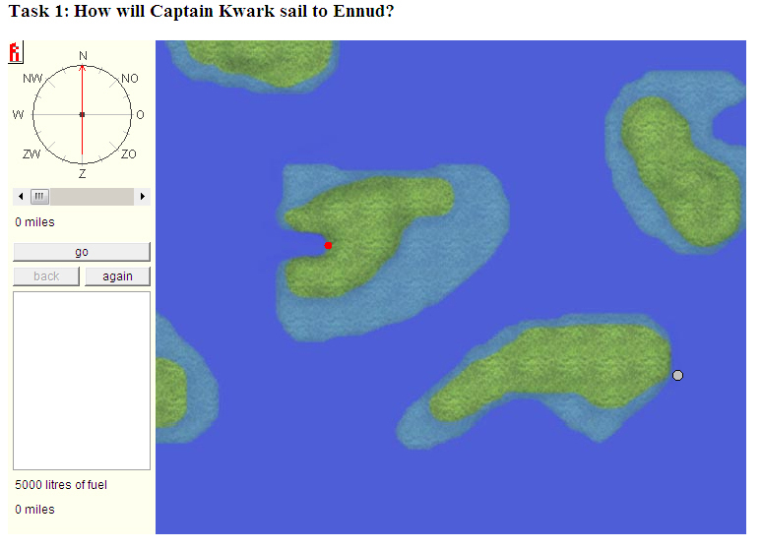

Question 1
How many miles is the shortest route?

Students are asked to find the shortest route from a position to a given destination. To solve this problem, students need to have good estimation of distance and direction. There many strategies to find routes that will lead to the shortest route. Students’ creativity is developed when they are investigating the various route and also the shortest route. Students may do trial and error, but a warning given in the direction (i.e. But watch out, every time you make a new direction, it will cost 10 liters of fuel extra!) aims to reduce the number of trial and error done by students.

Question 2
How many liters of fuel are there left after the trip?
The shorter the travelled distance, the less fuel is consumed. Therefore, this problem can also be used to help students learn about direct proportion. This problem can also be used to develop students’ sense on indirect proportion when we think the problem oppositely, that is the shorter the travelled distance, the more the fuel that remains. Students’ sense on indirect proportion is developed by this problem and, then, the teacher may give new problem about direct and indirect proportion.

- “What is the fastest way Captain Kwark can sail to Griendt?”
The questions in this problem are same with that of the first problem, namely:

Question 1
How many miles is the shortest route?

Question 2
How many liters of fuel are there left after the trip?
The difference between Problem 1 and Problem 2 is that the map in Problem 2 is given grids. By using the grids, the students move from an estimation of distance into a measurement of distance. The grids can also be used to develop students’ sense that the shortest distance of two points (in a plane) is a straight line connecting these points; and this point is the hypotenuse of a right triangle. Teacher may use this problem to introduce the Pythagorean Theorem by observing the length of hypotenuse and two other sides of a right triangle.
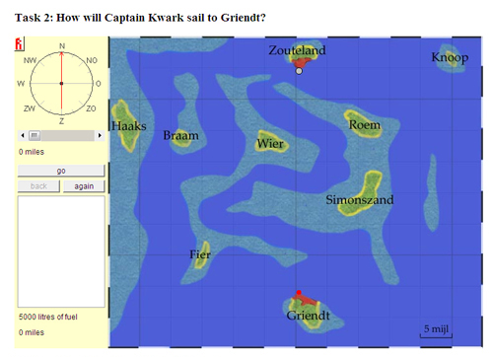

- “The small notes of Captain Kwark”
In Problem 3, students learn to determine direction of a given code. Students learn to read a code and translate it in a map.
Captain Kwark sails to four islands, he ends up at the island of Kim.
He has written down the four directions on four small notes.
But the notes have been messed up, so now he has the problem in which order he has to use the notes.
On every note you see a direction, e.g. ESE 25
that means 25 miles in the direction East South East.
Notice:
you may only use directions that are written on the notes,
and you only use them once.
These are the four notes:
notes: | SSW 32 | ESE 25 | N 15 | SW 15
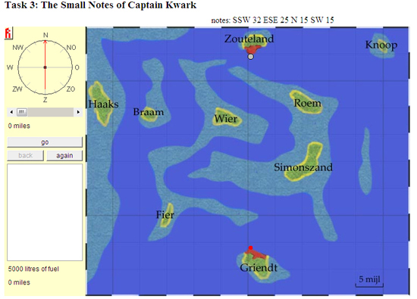

- “Captain Kwark goes shopping”
Problem 4 is the development of Problem 3, which is by reducing the direction. Students are given a list of distances without any direction. When students are given a fixed island and a distance, they are asked to estimate the next island which has this distance. This problem is about measurement of length in which students develop their estimation of distance between islands.
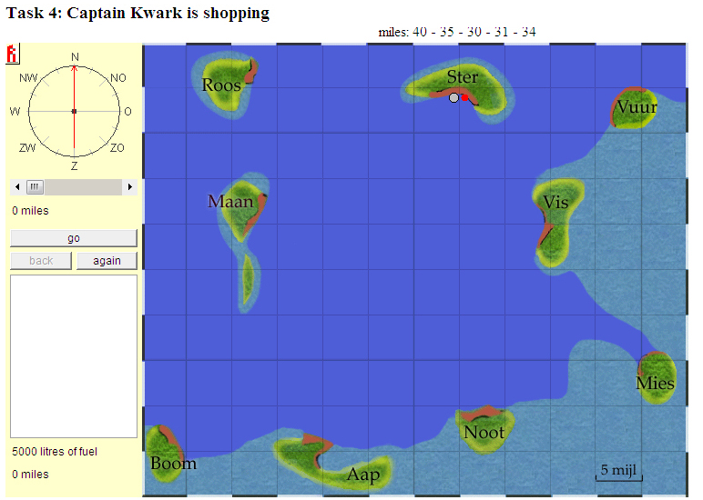

- Conclusion
Although the main topic of “Sailing” game is about navigation system (which is closely related to angle), there are various mathematics concepts which are embodied in this game, namely: angle, indirect proportion, measurement of length, indirect proportion and Pythagorean Theorem.
Students’ creativity is developed when they are investigating the shortest route in problem 1 since there are many possible routes to travel. Problem 2 also support the development of students’ creativity since students may take the advantage of the grids on the map. Teacher may develop problem 3 to develop students’ creativity, namely by giving tasks for students to plan their own journey and inform their journey to the others by giving the codes.

References:
Castle, K. & Needham, J. (2007). First Graders’ Understanding of Measurement. Early Childhood Education Journal 35, 215 – 221.
De Freitas, S. & Oliver, M. (2006). How can exploratory learning with games and simulations within curriculum be effectively evaluated? Computer & Education 46, 249 – 264.
Freudenthal, H. (1991). Revisiting Mathematics Education: China Lectures. Dordrecht, The Netherlands: Kluwer Academics Publisher.
Gravemeijer, K., Bowers, J. & Stephan, M. (2003). A hypothetical learning trajectory on measurement and flexible arithmetic. In: M. Stephan, J. Bowers, P. Cobb & K. Gravemeijer (Eds.), Supporting students’ development of measuring conceptions: Analyzing students’ learning in social context. Journal for Research in Mathematics Education Monograph 12, 51-66.
Haughland, S.W. & Wright, J.L. (1997). Young Children and Technology: A World of Discovery. Woonsocket: Allyn & Bacon
Henshaw, J.M. (2006). Does Measurement Measure up? How Numbers Reveal & Conceal the Truth. Baltimore: The Johns Hopkins University Press.
Joram, E. (2003). Benchmarks as Tools for Developing Measurement Sense. In Clement,
Pietarinen, A. V. (2003). Games as Formal Tools Versus Games as Explanations in Logic and Science. Foundations of Science 8, 317 – 364.
Sherin, M.G. (2002) A Balancing Act: Developing a Discourse Community in a Mathematics Community. Journal of Mathematics Teacher Education 5, 205 – 233.
Simon, M. A. & Tzur, Ron. (2004). Explicating the Role of Mathematical Tasks in Conceptual Learning: An Elaboration of the Hypothetical Learning Trajectory. Mathematical Thinking & Learning 6 (2), 91-104.
Treffers, A. (1987). Three Dimensions. A Model of Goal and Theory Description in Mathematics Instruction – The Wiskobas Project. Dordrecht, The Netherlands: Reidel Publishing Company.
Van de Wall, J. & Folk, S. (2005). Elementary and Middle School Mathematics. Teaching Developmentally. Toronto: Pearson Education Canada Inc
Zack, V. & Graves, B. (2001). Making mathematical meaning through dialogues: “Once you think of it the Z minus three seems pretty weird”. Educational studies in mathematics 46, 229-271.

International Seminar: The Faculty of Math and Natural Sciences, Yogyakarta State University

